Environmental Management Plan

Reconstruction Substations 110/35 kV/kV Petrovac

PE Electric power industry of Serbia

The Floods Emergency Recovery Project

January, 2015

Contents
INTRODUCTION 3
INSTITUTIONAL AND IMPLEMENTATION ARRANGEMENTS 3
COMPONENT 1: ENERGY SECTOR SUPPORT (EUR 157.11 MILLION) 3
RECONSTRUCTION SUBSTATIONS 110/35 kV/kV PETROVAC 4
FACILITY DESCRIPTION 4
ROLE OF THE FACILITY IN ELECTRICITY MARKET 5
REASONS FOR RECONSTRUCTION 5
DESCRIPTION OF TYPES AND MAXIMUM EXPECTED QUANTITIES OF HAZARDOUS SUBSTANCES 6
MATERIAL BALANCE OF HAZARDOUS SUBSTANCES IN TECHNOLOGICAL EQUIPMENT 6
SULFURIC ACID IS PRESENT IN RECHARGEABLE BATTERIES (ACCU). 7
MASS BALANCES OF HAZARDOUS SUBSTANCES AS WASTE 7
TECHNICAL AND TECHNOLOGICAL SPECIFICS OF STORAGE AND WORK WITH HAZARDOUS SUBSTANCES 8
IDENTIFICATION OF THE SOURCES OF DANGER 10
DESCRIOPTION OF WORKS AND MAIN IMPACTS 11
OVERVIEW OF SS PETROVAC 12
Annex 1 14
Annex 2 15

INTRODUCTION

This investment is a part of the Floods Emergency Recovery Project (FERP), which has been signed between the Government of Serbia and the World Bank (WB) on 09. October 2014.
The FERP focuses on delivering support to the priority sectors that were affected by the floods, as identified in the Recovery Needs Assessment (RNA). This includes support to the energy and agriculture sectors, and flood protection. The needs in the housing sector, which was also one of the hardest hit, have been addressed by the government through other donor support mechanisms, notably from the EU and the UN. The project would: (i) help close the financing gap and ensure continued provision of electricity services, particularly during the first winter following the floods; (ii) provide direct financial support to farmers in affected areas at a time when the fiscal accounts are under severe stress and may be unable to deliver the needed support; and (iii) help improve resilience to disasters by financing investments in critical flood prevention infrastructure.
The Project Development Objective (PDO) is to: (i) help restore power system capability to reliably meet domestic demand; (ii) protect livelihoods of farmers in flood affected areas; (iii) protect people and assets from floods; and (iv) improve the Borrower’s capacity to respond effectively to disasters.

INSTITUTIONAL AND IMPLEMENTATION ARRANGEMENTS

The project will be implemented over three years with a proposed closing date of December 31, 2017. Institutional arrangements and responsibilities of the different institutions are outlined below.
The Office for Reconstruction will be responsible for overseeing the overall project implementation. Project management functions and day to day operations will be the responsibility of EPS, the Directorate for Agrarian Payments (DAP) (with the support of Treasury), and the Project Implementation Unit (PIU).
The project consists of four components: (1) Energy Sector Support; (2) Agricultural Sector Support; (3) Flood Protection; and (4) Contingent Emergency Response.

COMPONENT 1: ENERGY SECTOR SUPPORT (EUR 157.11 MILLION)

The objective of this component is help restore power system capability to reliably meet domestic demand through power purchases, improved reliability of the distribution system and energy conservation measures, and help the restoration of strategic energy assets.
- Subcomponent 1A: Support for electricity purchases (EUR 119.82 million). Subcomponent 1A will support electricity purchases by EPS to improve power availability and avert an impending energy crisis particularly over the first winter heating season following the floods. The project would support power purchases made under commercial practices under multi-monthly, monthly, and weekly contracts. Retroactive financing for power import contracts from June 2014 to the signing of the Loan Agreement will also be considered carrying ex-post facto review for eligibility.
- Subcomponent 1B: Urgent restoration of the distribution network and load management (EUR 14.29 million). Subcomponent 1B will support the provision of: (i) metering devices for the flood affected areas; (ii) mobile substations; (iii) energy-efficient light bulbs, technical assistance, and other goods to support load management activities.
- Subcomponent 1C: Dewatering of the Tamnava West Field Mine (EUR 23 million). Subcomponent 1C will support the first critical step to put the Tamnava West Field Mine in the Kolubara mining basin back into operation and help avoid significant health hazards associated with the flooded mine, including the potential pollution of ground water, an increase in water-borne diseases, as well as threats to surrounding flora and fauna that would emerge as a result of stagnant water in the mine pit. Subsequent activities related to mine recovery and coal mining equipment rehabilitation will be undertaken by EPS and are outside the scope of this project.
Considering that the critical period for the EPS power system is behind us (2014/2015 winter season is over), installation of energy saving lamps is no longer necessary (sub-component 1B (iii)), which was also evident at the time when the credit arrangement was prepared. A load management study was foreseen under this component. EPS already has an energy efficiency study, which is a strategic document not including the procurement of energy saving lamps. For this reason, EPS proposes that the said funds may be utilized for other purposes. EPS is planning to use EUR 1.5 million to procure cabinets including electronic electricity meters instead of the planned EUR 4.1 million for the sub-component 1B (iii) with the aim to separate the distribution network from the public lighting installations. Furthermore, the remaining EUR 2.6 million could be reallocated for equipment purchase under the rehabilitation project for 5 out of 54 most critical substations 110/35 kV/kV recently taken over by EPS from EMS.
Energy Sector Support will be the responsibility of EPS. General management and support functions are assigned to its Head Office in Belgrade. EPS has designated a small team of staff (project implementation team) for the implementation of the proposed project to work under the Head of Strategy and Investment Department of EPS. The project implementation team’s main function is to prepare the Project Operations Manual (POM), coordinate with other corporate departments to ensure effective implementation of procurement, contracting, contract administration, disbursement, financial management, accounting, and reporting. This team is responsible for the submission of Financial Management Reports to the Bank. The project accounts will be maintained by the Finance Department of EPS.

RECONSTRUCTION SUBSTATIONS 110/35 kV/kV PETROVAC

FACILITY DESCRIPTION

Petrovac Substation (SS 110/35 kV Petrovac) has been operating with the installed 20 MVA unit since 1979 and additional 31,5 MVA since 1986. Facilities 110 kV and 35 kV were installed in the open space. This SS supplies the area of Petrovac and surrounding area and part of Žagubica municipality. This SS, supplied 159 million kWh in 2014 (with power factor that varies within the range 0.91-0.96 per months), around 157 million kWh a year before, and in 2012 - around 158 million kWh.
In the SS, five 110 kV overhead lines meet (two from SS Požarevac, one from TPP Morava, SS Bor 1 and SS Majdanpek 3), so it presents junction point in transmission network and is important from the aspect of power flows in transmission network. Five SS 35/10kV are supplied from this SS on 35 kV: Petrovac 1, Petrovac 2, Veliko Laole, Kalište and Aleksandrovac. From SS 110/35 kV Petrovac there is also a supply line 35 kV for SS 35/10 kV Krepoljin and Jelenac (that belong to the territory of former ED Bor within branch ”Elektrotimok“ of former subsidiary Jugoistok). Maximum load was recorded in December, 2014 and was 36.1 MW and 9 MVAr, i.e., around 37.2 MVA, which means that SS was loaded 72%. Beside the mentioned 35 kV connection from Krepoljin to busbars of SS 110/35 kV Petrovac, SS 110/35 kV Petrovac has only one realized connected 35 kV line with TPP Morava through the line with Al/Fe 50 mm2 cross section, 32 km long. This overhead line is in a very bad physical condition (1 km long part of overhead line is also missing), therefore it cannot be used as a help for supply of the endangered consumption area when transformer 110/35 kV is out of operation. In the event of smaller capacity transformer outage the reductions are necessary, so it is necessary to have at least 2x31.5 MVA installed apparent power in this SS.

ROLE OF THE FACILITY IN ELECTRICITY MARKET

Current and future role of this facility is the same: it represents junction point of transmission and distribution system and its purpose is electricity distribution in Petrovac municipality and the surrounding area (through the supply of the above mentioned five SS 35/10 kV) and in the part of Žagubica municipality (two above mentioned SS 35/10 kV). It also provides reserve supply for SS 35/10 kV Krst and Francuske Barake supplied from SS 110/35 kV Bor 1, and also help in the event of outage of transformer in the above mentioned SS 110/35 kV Bor 1. Beside this role, this facility is junction point for 110 kV network and provides different set-ups in transmission network that affect the supply of the surrounding SS 110/35 kV (Požarevac, Bor 1, Majdanpek 3) and the placement of power from TPP Morava (i.e. voltages in this part of transmission system). If the entire facility would be left without supply due to major failure on 110 kV, in addition to five SS 35/10 kV for which reserve would not be possible to provide, the operation of transmission network would be endangered as well. Schematic links in respect to existing and future operation of Petrovac SS is shown in Annex 1.
Taking into consideration the development of 35 kV network in this SS is necessary to foresee furnishing of five feeders in new 35 kV facility.

REASONS FOR RECONSTRUCTION

Having in mind the fact that the role of this facility will remain the same in distribution system, the main reasons for its reconstruction are increase of installed capacity to 2x31.5 MVA and presence of the old equipment in SS. 110 kV and 35 kV facilities in this SS are in the open space. Transformers have been operating since 1979 (20 MVA unit) and 1986 (31.5 MVA unit), therefore, they are close to the end of useful life. Even though five 110 kV circuit breakers have been operating since 1961, two since 1974, one since 1984, and only one since 2002. Situation is somewhat better with 35 kV facility where circuit breakers are in three bays from 1974, in two from eighties of the last century (1984 and 1988) and in one from 2006. From the aspect of age, the situation is also bad with 110 kV disconnectors (for one the age is unknown, 15 are from 1961, 7 from 1974, and only three are from the eighties of the twentieth century). 35 kV disconnectors are a bit younger (11 are from the middle of the seventies – 1974 and 1976, and 12 from 1984). Few 110 kV current measuring transformers were reconstructed (nine single pole are from 2008 or later, three from 2002, and the rest are from the end of seventies or the beginning of eighties of the last century). 35 kV current measuring transformers are mostly from 1970’s and 1980’s, except in one 35 kV bay where they were installed in 2007. 110 kV voltage transformers are only in one bay from 2002, and for one phase in the other bay from 2013. The others are mostly from the middle of seventies (1974 and 1977) and eighties (1984). Surge arresters are partly replaced during 2009 (three on 110 kV and three on 35 kV). The rest are from the end of seventies and the beginning of eighties. Elements of own consumption are mostly outdated: except for rechargeable batteries that were replaced in 2002 and 2009, converters are old (from 1975 and 1979), inverters (from 1981) and own consumption transformer (from 1968).
The average age of equipment elements in this SS is almost forty - which means that SS is ready for the complete reconstruction. For the increase of reliability and lower construction costs the construction of 35 kV inside the facility is necessary, which means that during designing and construction the part of 35 kV facility that is in the open should be relocated to the available space, or the disposition of lines should be changed (or even partial cabling to the first poles outside the facility) to provide the space for the construction of the facility.

DESCRIPTION OF TYPES AND MAXIMUM EXPECTED QUANTITIES OF HAZARDOUS SUBSTANCES

In SS Petrovac, hazardous substances are present:
- in technical and technological equipment,
- as waste.

Total quantity of hazardous substances that may be discovered at the location for any reason is given in Table 1.
NAME | PROCESS POINT |  |  |  |  |  |  | MASS BALANCE  (tons)
Generic, chemical and other  and  chemical substances formula | Raw material | Intermediate product | Byproduct | Final product | Waste | Transport  Turnover | Storage | Max. daily | Middle monthly | Total annual
1 | 2 | 3 | 4 | 5 | 6 | 7 | 8 | 9 | 10 | 11
Transformer oil | X |  |  |  |  |  |  | 34.76 |  | 34.76
Sulfuric acid | X |  |  |  |  |  |  | 1.21 |  | 1.21

Table 1. Quantity of hazardous substances at the location (Form III)

MATERIAL BALANCE OF HAZARDOUS SUBSTANCES IN TECHNOLOGICAL EQUIPMENT

In technical and technological equipment, the following hazardous substances are present:
- Transformer oil,
- Sulfuric acid.
Transformer oil is present in transformers (T) and in high-voltage (HV) equipment (circuit breakers and current measuring transformers).

SULFURIC ACID IS PRESENT IN RECHARGEABLE BATTERIES (ACCU).

Description of separate and total quantities of oil and sulfuric acid within technical and technological equipment is given in Table 2.

Device-equipment | Type of hazardous substance | Quantity in device | Total quantity
Т-1 | Transformer oil | 16.00 t | 29.00t
Т-2 | Transformer oil | 13.00 t
HV equipment | Transformer oil | 5.76 t | 5.76 t
ACCU-batteries | Accu H₂SО₄ | 1.00 t | 1.00 t

Table 2. Types and quantities of hazardous substances in technical and technological equipment

MASS BALANCES OF HAZARDOUS SUBSTANCES AS WASTE

The quantity of oily wastewaters from oil pit depends on the atmospheric impact i.e. the quantity of precipitation. Dimensions of oil sump are: 6.00 m x 3.50 m, so the quantity of these waters is estimated according to the following formula:

Q = q . F. s. j. n [l/s]

where: q-is quantity of rain, [l/sha]; F- catchment area, [ha]; s-outflow coefficient; ј-precipitation reduction coefficient; n-outflow delay coefficient.
For q= 120 [l/sha], oil bath surface F [ha], s=0.008 , ј=0.006; n=1,2, calculated quantity of water that originates from atmospheric impact from 1 oil bath is:

Q= 0.0206 [l/s]

Solid oily waste originates from residue from oil pit after its cleaning. It is estimated according to expert and practical experience that it amounts to around 5% out of total quantity of oily waters that are produced during the year.

Type of hazardous substance | Quantity, [kg/year]
Oily water and oil emulsion | 6,306
Solid oily waste | 315

Table 3. Estimated types and quantities of hazardous waste produced during the year
The quantity of wastewater coming from sanitary equipment is defined according to the specified number of consumers. They go into the sewer system of the city.

Consumer | Number of consumers | Total consumption, [l/s]
WC | 2 | 0.14
Washstand | 2 | 0.04
Shower | 1 | 0.07
 | TOTAL | 0.25

Table 4. Estimated types of sanitary waters

TECHNICAL AND TECHNOLOGICAL SPECIFICS OF STORAGE AND WORK WITH HAZARDOUS SUBSTANCES

А) Oil for transformers and high-voltage equipment
There is significant amount of transformer oil of mineral origin in SS "Petrovac" and in terms of environmental impact it is the only important one.
Characteristics of transformer oil in terms of environmental impacts are provided in Table 5.

According to the European Agreement concerning the International Carriage of Dangerous Goods by Roads, ADR code
 | Class and  serial number |  | WHC – I (low danger to water)
 | Substance ID number |  | 54106
 | Danger label |  | GGVS/ADR, ADNR/AND,, GGVE/RID, UN, IATA/DGR, GGV See/IMDG
1. | Numerical substance symbol  (According to the list of hazardous substances of the United Nations or UN number) |  | RL 67/548/EWG, RL 88/379/EWG
2 | Description:  Mineral oil inhibited by 2,6-Di-tert-butyl-p-cresol BHT
3. | Physical and chemical characteristics
 |  | Concentration in % | 100
 |  | State of aggregation (physical condition description) | liquid
 |  | Ignition point (^{о}C) | 143 °C
 |  | Explosion limit % (zap) | 0.6-6.5
 |  | Decomposition due to high temperature (^{о}C) | above 360
4. | (ECO) Toxicological characteristics
 |  | Toxic | X
 |  | Flammable liquids | X
5. | Point of hazardous substance in the process
 |  | Raw material | X
6. | Mass and volume balances (in kg, t, l, m³)
 |  | Total annual | 34.76 t

Table 5. Form II- Characteristics of transformer oil

B) Battery acid
For battery charging 75% sulfuric acid is used.
Features: according to JUS Z.CO 005/79 degree of toxicity is 3; degree of flammability 0; degree of reactivity 1;
Maximum allowed concentration: according to JUS Z.BО.001/71 maximum allowed concentrations in air of the working environment is 1mg/m³.
Flammability and explosiveness: Sulfuric acid and its vapors are not flammable.
Fire danger: Sulfuric acid does not burn or support combustion, but concentrated acid can cause ignition of many substances, for example: wood, paper, cotton and other combustible substances.
Environmental protection: Waste water containing sulfuric acid must be neutralized prior to discharging into the public sewer system or in the receiving watercourses.

IDENTIFICATION OF THE SOURCES OF DANGER

Based on the analysis of technical documentation and accident events on this SS in the last 5 years and examining the condition of SS on the site, data about the possible failure of SS system components are obtained, which would result in endangering the environment with hazardous substances.

Fault tree and accidents development schemes

Based on analyzed sources of danger on SS "Petrovac", the following failures with accidents development schemes and impact on the environment are systematized, and are presented in the following schemes:

Oil leakage
Destruction of Т
Fracture of armature, pipes, damage of covering
Mechanical explosion of Т
Fire in T

Oil bath

Soil

Shock wave
Soil contamination
Demolition, burning, injuries
Thermal radiation
Products
Air pollution
Protective box
Hazardous waste
Oil pit
Figure 1. Scheme of accident development at transformer destruction

Destruction of HV equipment
Oil leakage

Soil
Soil contamination

Figure 2. Scheme of accident development at HV failure or loss of sealing properties of equipment connections

Destruction of oil pit
Oil leakage

Soil
Soil contamination

Figure 3. Scheme of accident development during leaks or overflow of oil pit and/or bath

Failure in ACCU battery
Damage of ACCU covering
H₂ cloud
Fire in SS
Leakage H₂SO₄
Floor of ACCU ba.
Shock wave
Demolition, burning, injuries
Thermal radiation
Products
Air pollution
The room of ACCU battery
Protective pit
Hazardous waste

Explosion
Organic substancess
Figure 4. Scheme of accident development at failure of some element in ACCU battery

DESCRIOPTION OF WORKS AND MAIN IMPACTS

Preliminary Design with Feasibility Study is elaborated by Elektroistok inzenjering d.o.o. and Elektrotehnicki institute Nikola Tesla A.D. According to mentioned documents proposed works include:
- Leveling plateau.
- Construction of trails and new cable channels.
- Adaptation/rehabilitation of existing command building.
- Construction of a new 35 kV facility.
- The demolition and removal of the old existing 35 kV facility.
- Replacement of the complete fence and reconstruction of existing drainage channel around the rim of the plateau. (See Annex 1).
All the land on which the building is located is owned by EPS Distribucija. By the Contract No. 8772 dated 11.09.2014, the Republic of Serbia has provided real estate for management and use by the Government Conclusion 05 No.: 46-9323/2013 dated November 1st, 2013. All activities regarding reconstruction will be performed within the fenced area of SS and further expansion outside the existing, fenced lot, is not foreseen. There are no private persons that are related to this land.
The environmental impacts during execution of civil works will be limited to the ones which are common to all construction activities - air, dust and noise pollution, vibrations and local soil and possibly groundwater disturbance. The negative impacts will be felt only temporarily (during the works execution) and their impacts will be limited. However, application of good engineering practices and proper site and contract control will contribute to minimize or avoid negative impacts altogether.
HAZARDOUS WASTE
The waste is presently stored in electrical equipment according to Table 2. The waste will be removed according to management plan which will be delivered by contractor and approved by EPS representatives. Plan of all works (removal, transport and waste disposal) must be in accordance with all current relevant international and Serbian legislatives. Contractor is obligated to remove and dispose/deliver/store all equipment at the EPS warehouse in Pozarevac, according to the plan and internal EPS Distribucija procedures related to ISO 14001 standard.
In order to avoid, prevent or mitigate the potential occupational and community health and safety risks, potential environmental impacts on air quality, underground waters, noise disturbance, waste generation and management, the good demolition/construction practice implementing several mitigation measures is proposed within the following Environmental Mitigation/Monitoring Plan- EMP. (Annex 2)
The main responsibility for implementation of EMP related measures lays on the Contractor/Subcontractor, who needs to take into the account and applies on daily basis all proposed preventive and mitigation measures. The Site Supervisor needs to perform the supervision on the practical implementation of the mitigation measures by the Contractor/Sub-contractor, and issue corrective instructions and/or orders, if necessary.
The Project Implementation Unit will also coordinate the overall working plan related to construction schedules, implementation progress and implementation of proposed measures for avoidance and/or minimization of environmental, health and safety risks.

OVERVIEW OF SS PETROVAC

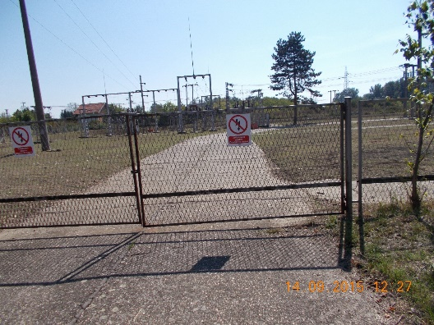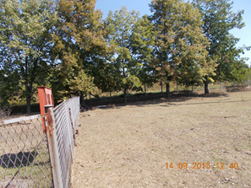
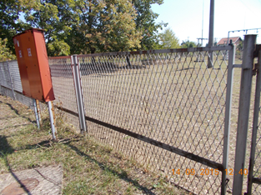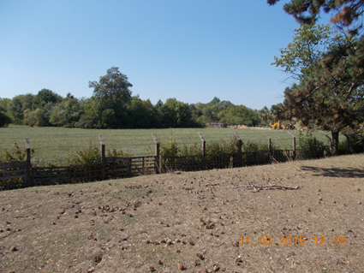
Picture 1. Switchyard overview

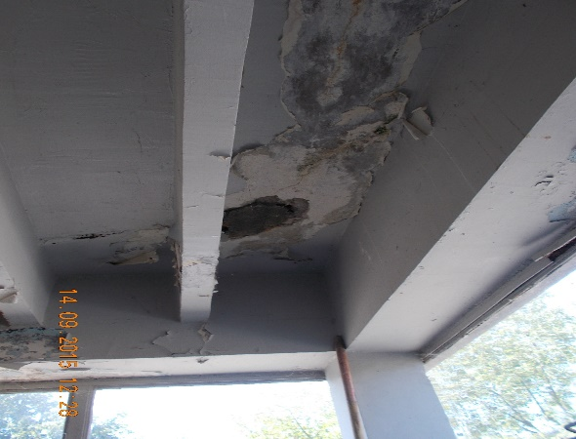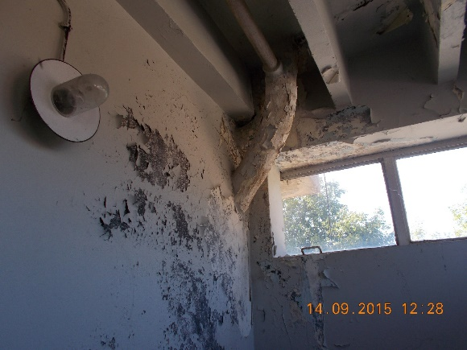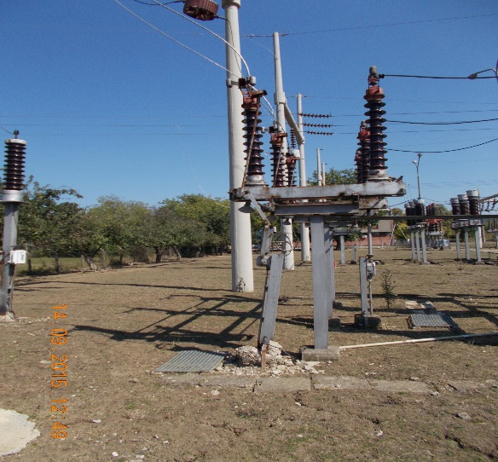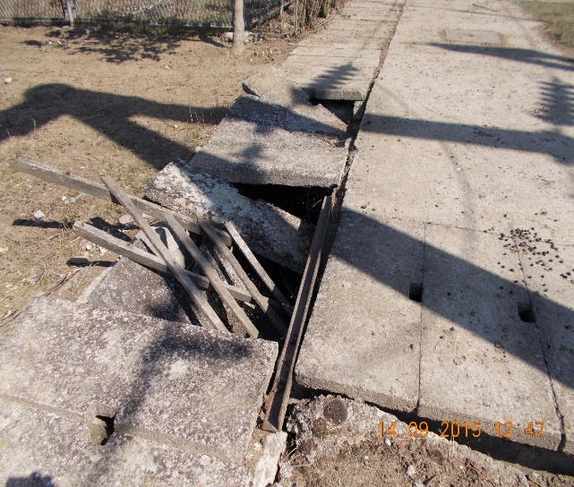
Picture 2. Building and electrical facility overview

Annex 1

Annex 2

