Environmental Management Plan

Reconstruction Substations 110/35 kV/kV Gornji Milanovac

PE Electric Power Industry of Serbia

The Floods Emergency Recovery Project

January, 2016

Contents
INTRODUCTION 3
INSTITUTIONAL AND IMPLEMENTATION ARRANGEMENTS 3
COMPONENT 1: ENERGY SECTOR SUPPORT (EUR 157.11 MILLION) 3
RECONSTRUCTION SUBSTATIONS 110/35 kV/kV GORNJI MILANOVAC 1 4
FACILITY DESCRIPTION 4
DESCRIPTION OF TYPES AND MAXIMUM EXPECTED QUANTITIES OF HAZARDOUS SUBSTANCES 5
MATERIAL BALANCE OF HAZARDOUS SUBSTANCES IN TECHNOLOGICAL EQUIPMENT 6
Sulfuric acid is present in rechargeable batteries (ACCU). 6
MASS BALANCES OF HAZARDOUS SUBSTANCES AS WASTE 7
TECHNICAL AND TECHNOLOGICAL SPECIFICS OF STORAGE AND WORK WITH HAZARDOUS SUBSTANCES 8
IDENTIFICATION OF THE SOURCES OF DANGER 9
DESCRIOPTION OF WORKS AND MAIN IMPACTS 10
OVERVIEW OF SS GORNJI MILANOVAC 12
Annex 1 14
Annex 2 15

INTRODUCTION

This investment is a part of the Floods Emergency Recovery Project (FERP), which has been signed between the Government of Serbia and the World Bank (WB) on 09. October 2014.
The FERP focuses on delivering support to the priority sectors that were affected by the floods, as identified in the Recovery Needs Assessment (RNA). This includes support to the energy and agriculture sectors, and flood protection. The needs in the housing sector, which was also one of the hardest hit, have been addressed by the government through other donor support mechanisms, notably from the EU and the UN. The project would: (i) help close the financing gap and ensure continued provision of electricity services, particularly during the first winter following the floods; (ii) provide direct financial support to farmers in affected areas at a time when the fiscal accounts are under severe stress and may be unable to deliver the needed support; and (iii) help improve resilience to disasters by financing investments in critical flood prevention infrastructure.
The Project Development Objective (PDO) is to: (i) help restore power system capability to reliably meet domestic demand; (ii) protect livelihoods of farmers in flood affected areas; (iii) protect people and assets from floods; and (iv) improve the Borrower’s capacity to respond effectively to disasters.

INSTITUTIONAL AND IMPLEMENTATION ARRANGEMENTS

The project will be implemented over three years with a proposed closing date of December 31, 2017. Institutional arrangements and responsibilities of the different institutions are outlined below.
The Office for Reconstruction will be responsible for overseeing the overall project implementation. Project management functions and day to day operations will be the responsibility of EPS, the Directorate for Agrarian Payments (DAP) (with the support of Treasury), and the Project Implementation Unit (PIU) established under DWM (see Figure 1 below).
The project consists of four components: (1) Energy Sector Support; (2) Agricultural Sector Support; (3) Flood Protection; and (4) Contingent Emergency Response.

COMPONENT 1: ENERGY SECTOR SUPPORT (EUR 157.11 MILLION)

The objective of this component is help restore power system capability to reliably meet domestic demand through power purchases, improved reliability of the distribution system and energy conservation measures, and help the restoration of strategic energy assets.
- Subcomponent 1A: Support for electricity purchases (EUR 119.82 million). Subcomponent 1A will support electricity purchases by EPS to improve power availability and avert an impending energy crisis particularly over the first winter heating season following the floods. The project would support power purchases made under commercial practices under multi-monthly, monthly, and weekly contracts. Retroactive financing for power import contracts from June 2014 to the signing of the Loan Agreement will also be considered carrying ex-post facto review for eligibility.
- Subcomponent 1B: Urgent restoration of the distribution network and load management (EUR 14.29 million). Subcomponent 1B will support the provision of: (i) metering devices for the flood affected areas; (ii) mobile substations; (iii) energy-efficient light bulbs, technical assistance, and other goods to support load management activities.
- Subcomponent 1C: Dewatering of the Tamnava West Field Mine (EUR 23 million). Subcomponent 1C will support the first critical step to put the Tamnava West Field Mine in the Kolubara mining basin back into operation and help avoid significant health hazards associated with the flooded mine, including the potential pollution of ground water, an increase in water-borne diseases, as well as threats to surrounding flora and fauna that would emerge as a result of stagnant water in the mine pit. Subsequent activities related to mine recovery and coal mining equipment rehabilitation will be undertaken by EPS and are outside the scope of this project.
Considering that the critical period for the EPS power system is behind us (2014/2015 winter season is over), installation of energy saving lamps is no longer necessary (sub-component 1B (iii)), which was also evident at the time when the credit arrangement was prepared. A load management study was foreseen under this component. EPS already has an energy efficiency study, which is a strategic document not including the procurement of energy saving lamps. For this reason, EPS proposes that the said funds may be utilized for other purposes. EPS is planning to use EUR 1.5 million to procure cabinets including electronic electricity meters instead of the planned EUR 4.1 million for the sub-component 1B (iii) with the aim to separate the distribution network from the public lighting installations. Furthermore, the remaining EUR 2.6 million could be reallocated for equipment purchase under the rehabilitation project for 5 out of 54 most critical substations 110/35 kV/kV recently taken over by EPS from EMS.
Energy Sector Support will be the responsibility of EPS. General management and support functions are assigned to its Head Office in Belgrade. EPS has designated a small team of staff (project implementation team) for the implementation of the proposed project to work under the Head of Strategy and Investment Department of EPS. The project implementation team’s main function is to prepare the Project Operations Manual (POM), coordinate with other corporate departments to ensure effective implementation of procurement, contracting, contract administration, disbursement, financial management, accounting, and reporting. This team is responsible for the submission of Financial Management Reports to the Bank. The project accounts will be maintained by the Finance Department of EPS.

RECONSTRUCTION SUBSTATIONS 110/35 kV/kV GORNJI MILANOVAC

FACILITY DESCRIPTION

SS 110/35 kV Gornji Milanovac has been in operation since seventies of the last century (1974), and its current installed capacity is 2 x 31.5 MVA – one 31.5 MVA transformer has been in operation since 1978 (T2) and the other one of the capacity of 31.5 MVA (T1) has been installed this year as the second unit.
In the SS itself, two 110 kV power lines meet, one of them, from 220/110 KV Pozega SS direction, and the other one, from 220/110 KV Cacak 3 SS direction. When 35 kV is concerned, nine 35/10 kV SS in total are supplied from this SS: four city 35/10 kV SS – Gornji Milanovac 1-4, as well as 35/10 kV SS: Rudnik, Bersici, Brezak, Takovo and Brdjani. Supply of the mentioned consumption area is carried out through eight 35 kV busbar connections, at which occasion it should be pointed out that two feeders for 35/10 kV Milanovac 4 SS are connected in one 35 kV bay, precisely due to the lack of space in 110/35 kV Gornji Milanovac SS. Maximum load on 35 kV side in 2014 was recorded in November, when it amounted to 38 MW and 11.4 MVAr, which represents load of 38.2 MW and 14 MVAr on 110 kV side, i.e. around 40.7 MVA, which means that the SS was loaded 65 % compared to installed capacity.

ROLE OF THE FACILITY IN ELECTRICITY MARKET
Present role, as well as the future role, of this facility is the same: it accounts for a place of connection of transmission and distribution systems and its purpose is distribution of electric energy in Gornji Milanovac municipality (through supply of mentioned 35/10 kV SS). Thus, this SS enables electricity supply of more than 44000 inhabitants of Gornji Milanovac municipality. From direction of this SS a stand-by supply of 35/10kV Jarmenovci SS (supplied from 110/35/10 kV Topola SS) and partial stand-by supply of 35/10 kV Separacija SS (supplied from 110/35/10 kV Cacak 2 SS) and 35/10 kV Cacak 4 SS (supplied from 110/35 kV Cacak 1 SS), is provided.

REASONS FOR RECONSTRUCTION
Aim of investing in reconstruction of SS 110/35 kV Gornji Milanovac is to provide secure and quality supply of all electricity customers on the territory of municipality Gornji Milanovac and some parts of the neighbouring municipalities. Also, the reconstructed SS will be good support in electricity supply in the events of transformer 110/35 kV failure in neighbouring SS 110/X kV Cacak 1, Cacak 2 and Topola, as well as in the events of the failure of some feeders for SS 35/10 kV, supplied by the SS and which are connected with SS 110/35 kV Gornji MIlanovac with 35 kV network: SS 35/10 kV Cacak 4, Separacija i Jarmenovci.
Having in mind the fact that the role of this facility within distribution system shall not be changed, core reason for its reconstruction is deterioration of the equipment in SS. Facilities 110kV and 35 kV are placed outdoor.
Average age of elements of the equipment in this SS is over thirty five years and general conclusion would be that the equipment is obsolete and it has to be replaced, which practically means that this SS is ready for overall reconstruction. For the purpose of reliability increase and lower construction costs, the construction of an indoor 35 kV facility is necessary, which means that during designing and construction, the part of outdoor 35 kV facility should be relocated to available space, or disposition of the lines should be changed (or even partial cabling up to first outdoor poles) in order to provide space for the facility construction.

DESCRIPTION OF TYPES AND MAXIMUM EXPECTED QUANTITIES OF HAZARDOUS SUBSTANCES

In SS Gornji Milanovac, hazardous substances are present:
- in technical and technological equipment,
- as waste.

Total quantity of hazardous substances that may be discovered at the location for any reason is given in Table 1.

NAME | PROCESS POINT |  |  |  |  |  |  | MASS BALANCE  (tons)
Generic, chemical and other  and  chemical substances formula | Raw material | Intermediate product | Byproduct | Final product | Waste | Transport  Turnover | Storage | Max. daily | Middle monthly | Total annual
1 | 2 | 3 | 4 | 5 | 6 | 7 | 8 | 9 | 10 | 11
Transformer oil | X |  |  |  |  |  |  | 54.9 |  | 54.9
Sulfuric acid | X |  |  |  |  |  |  | 0.239 |  | 0.239
Table 1. Quantity of hazardous substances at the location (Form III)

MATERIAL BALANCE OF HAZARDOUS SUBSTANCES IN TECHNOLOGICAL EQUIPMENT

In technical and technological equipment, the following hazardous substances are present:
- Transformer oil,
- Sulfuric acid.
Transformer oil is present in transformers (T) and in high-voltage (HV) equipment (circuit breakers and current measuring transformers).

Sulfuric acid is present in rechargeable batteries (ACCU).
Description of separate and total quantities of oil and sulfuric acid within technical and technological equipment is given in Table 2.

Device-equipment | Type of hazardous substance | Quantity in device | Total quantity
Т-1 | Transformer oil | 19.0 t | 50.5 t
Т-2 | Transformer oil | 31.5 t
HV equipment | Transformer oil | 4.4 t | 4.4 t
ACCU-batteries | Accu H₂SО₄ | 0.3 t | 0.3 t
Table 2. Types and quantities of hazardous substances in technical and technological equipment

MASS BALANCES OF HAZARDOUS SUBSTANCES AS WASTE

The quantity of oily wastewaters from oil pit depends on the atmospheric impact i.e. the quantity of precipitation. Dimensions of oil sump are: 6.00 m x 3.50 m, so the quantity of these waters is estimated according to the following formula:

Q = q . F. s. j. n [l/s]

where: q-is quantity of rain, [l/sha]; F- catchment area, [ha]; s-outflow coefficient; ј-precipitation reduction coefficient; n-outflow delay coefficient.
For q= 120 [l/sha], oil bath surface F [ha], s=0.008 , ј=0.006; n=1, calculated quantity of water that originates from atmospheric impact from 1 oil bath is:

Q= 0.00002022 [l/s]

Solid oily waste originates from residue from oil pit after its cleaning. It is estimated according to expert and practical experience that it amounts to around 5% out of total quantity of oily waters that are produced during the year.

Type of hazardous substance | Quantity, [kg/year]
Oily water and oil emulsion | 6,376
Solid oily waste | 319
Table 3. Estimated types and quantities of hazardous waste produced during the year
The quantity of wastewater coming from sanitary equipment is defined according to the specified number of consumers. They go into the sewer system of the city.

Consumer | Number of consumers | Total consumption, [l/s]
WC | 2 | 0.14
Washstand | 2 | 0.04
Shower | 1 | 0.07
 | TOTAL | 0.25
Table 4. Estimated types of sanitary waters

TECHNICAL AND TECHNOLOGICAL SPECIFICS OF STORAGE AND WORK WITH HAZARDOUS SUBSTANCES

А) Oil for transformers and high-voltage equipment
There is significant amount of transformer oil of mineral origin in SS "Gornji Milanovac" and in terms of environmental impact it is the only important one.
Characteristics of transformer oil in terms of environmental impacts are provided in Table 5.

According to the European Agreement concerning the International Carriage of Dangerous Goods by Roads, ADR code
 | Class and  serial number |  | WHC – I (low danger to water)
 | Substance ID number |  | 54106
 | Danger label |  | GGVS/ADR, ADNR/AND,, GGVE/RID, UN, IATA/DGR, GGV See/IMDG
1. | Numerical substance symbol  (According to the list of hazardous substances of the United Nations or UN number) |  | RL 67/548/EWG, RL 88/379/EWG
2 | Description:  Mineral oil inhibited by 2,6-Di-tert-butyl-p-cresol BHT
3. | Physical and chemical characteristics
 |  | Concentration in % | 100
 |  | State of aggregation (physical condition description) | liquid
 |  | Ignition point (^{о}C) | 143 °C
 |  | Explosion limit % (zap) | 0.6-6.5
 |  | Decomposition due to high temperature (^{о}C) | above 360
4. | (ECO) Toxicological characteristics
 |  | Toxic | X
 |  | Flammable liquids | X
5. | Point of hazardous substance in the process
 |  | Raw material | X
6. | Mass and volume balances (in kg, t, l, m³)
 |  | Total annual | 54.9 t
Table 5. Form II- Characteristics of transformer oil

B) Battery acid
For battery charging 75% sulfuric acid is used.
Features: according to JUS Z.CO 005/79 degree of toxicity is 3; degree of flammability 0; degree of reactivity 1;
Maximum allowed concentration: according to JUS Z.BО.001/71 maximum allowed concentrations in air of the working environment is 1mg/m³.
Flammability and explosiveness: Sulfuric acid and its vapors are not flammable.
Fire danger: Sulfuric acid does not burn or support combustion, but concentrated acid can cause ignition of many substances, for example: wood, paper, cotton and other combustible substances.
Environmental protection: Waste water containing sulfuric acid must be neutralized prior to discharging into the public sewer system or in the receiving watercourses.

IDENTIFICATION OF THE SOURCES OF DANGER

Based on the analysis of technical documentation and accident events on this SS in the last 5 years and examining the condition of SS on the site, data about the possible failure of SS system components are obtained, which would result in endangering the environment with hazardous substances.

Fault tree and accidents development schemes

Based on analyzed sources of danger on SS "Gornji Milanovac", the following failures with accidents development schemes and impact on the environment are systematized, and are presented in the following schemes:

Oil leakage
Destruction of Т
Fracture of armature, pipes, damage of covering
Mechanical explosion of Т
Fire in T

Oil bath

Soil

Shock wave
Soil contamination
Demolition, burning, injuries
Thermal radiation
Products
Air pollution
Protective box
Hazardous waste
Oil pit
Figure 1. Scheme of accident development at transformer destruction
Destruction of HV equipment
Oil leakage

Soil
Soil contamination

Figure 2. Scheme of accident development at HV failure or loss of sealing properties of equipment connections

Destruction of oil pit
Oil leakage

Soil
Soil contamination

Figure 3. Scheme of accident development during leaks or overflow of oil pit and/or bath

Failure in ACCU battery
Damage of ACCU covering
H₂ cloud
Fire in SS
Leakage H₂SO₄
Floor of ACCU ba.
Shock wave
Demolition, burning, injuries
Thermal radiation
Products
Air pollution
The room of ACCU battery
Protective pit
Hazardous waste

Explosion
Organic substancess
Figure 4. Scheme of accident development at failure of some element in ACCU battery

DESCRIOPTION OF WORKS AND MAIN IMPACTS

Preliminary Design with Feasibility Study is elaborated by Elektroistok inzenjering d.o.o. and Elektrotehnicki institute Nikola Tesla A.D. According to mentioned documents proposed works include:
- Leveling plateau.
- Construction of trails and new cable channels.
- Adaptation/rehabilitation of existing command building.
- Construction of a new 35 kV facility.
- The demolition and removal of the old existing 35 kV facility.
- Replacement of the complete fence and reconstruction of existing drainage channel around the rim of the plateau. (See Annex 1).

All the land on which the building is located is owned by EPS Distribucija. By the Contract No. 8772 dated 11.09.2014, the Republic of Serbia has provided real estate for management and use by the Government Conclusion 05 No.: 46-9323/2013 dated November 1st, 2013. All activities regarding reconstruction will be performed within the fenced area of SS and further expansion outside the existing, fenced lot, is not foreseen. There are no private persons that are related to this land.
The environmental impacts during execution of civil works will be limited to the ones which are common to all construction activities - air, dust and noise pollution, vibrations and local soil and possibly groundwater disturbance. The negative impacts will be felt only temporarily (during the works execution) and their impacts will be limited. However, application of good engineering practices and proper site and contract control will contribute to minimize or avoid negative impacts altogether.
HAZARDOUS WASTE
The waste is presently stored in electrical equipment according to Table 2. The waste will be removed according to management plan which will be delivered by contractor and approved by EPS representatives. Plan of all works (removal, transport and waste disposal) must be in accordance with all current relevant international and Serbian legislatives. Contractor is obligated to remove and dispose/deliver/store all equipment at the EPS warehouse in Gornji Milanovac, according to the plan and internal EPS Distribucija procedures related to ISO 14001 standard.
In order to avoid, prevent or mitigate the potential occupational and community health and safety risks, potential environmental impacts on air quality, underground waters, noise disturbance, waste generation and management, the good demolition/construction practice implementing several mitigation measures is proposed within the following Environmental Mitigation/Monitoring Plan- EMP. (Annex 2)
The main responsibility for implementation of EMP related measures lays on the Contractor/Subcontractor, who needs to take into the account and applies on daily basis all proposed preventive and mitigation measures. The Site Supervisor needs to perform the supervision on the practical implementation of the mitigation measures by the Contractor/Sub-contractor, and issue corrective instructions and/or orders, if necessary.
The Project Implementation Unit will also coordinate the overall working plan related to construction schedules, implementation progress and implementation of proposed measures for avoidance and/or minimization of environmental, health and safety risks.

OVERVIEW OF SS GORNJI MILANOVAC

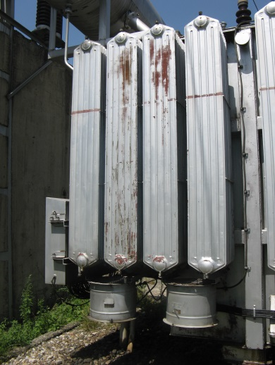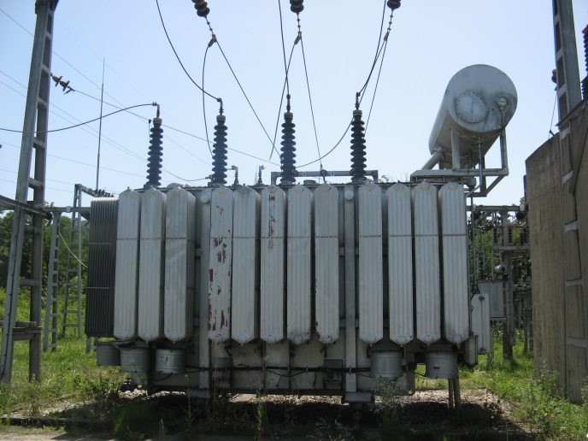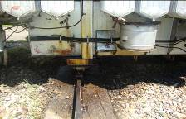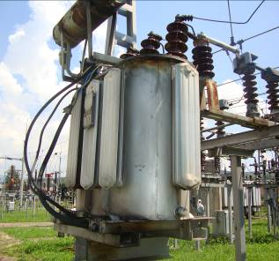
Picture 1. Transformers overview

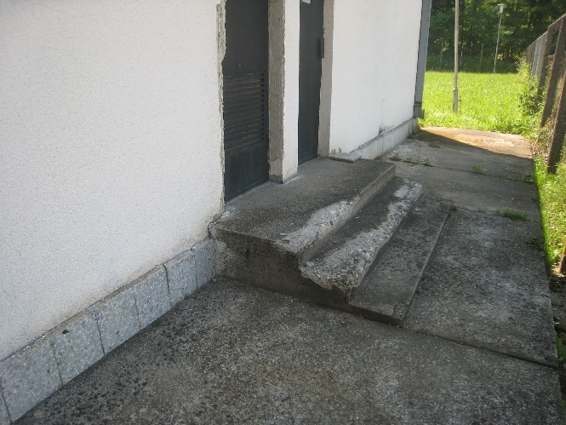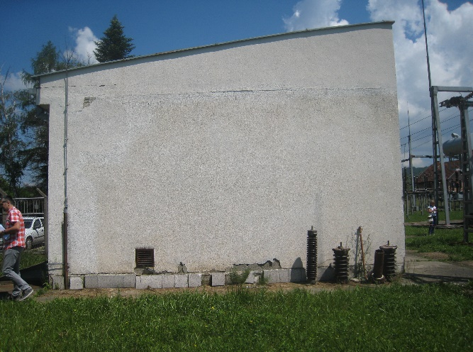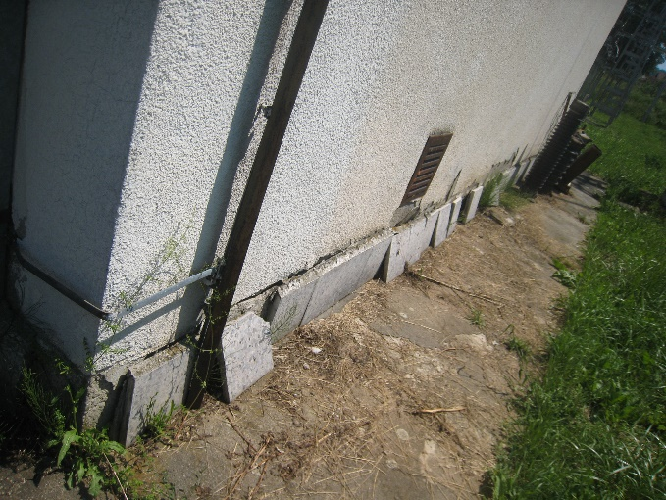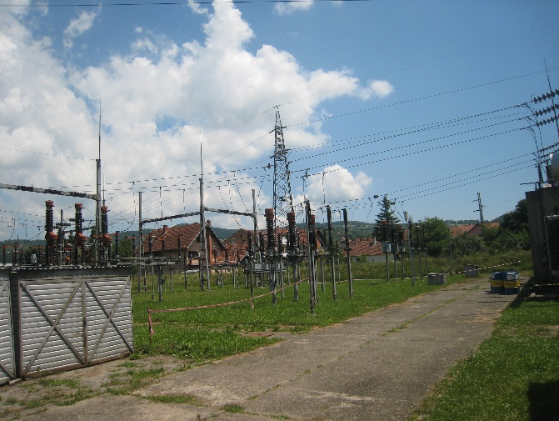
Picture 2. Building and electrical facility overview

Annex 1

Annex 2

