

PUBLIC ENTERPRISE ELECTRIC POWER INDUSTRY OF SERBIA

Annual Report on Cooperation with
Stakeholders for 2022

Contents

1.Introduction 3
2.Report Preparation Methodology 4
3.Main Activities of PE EPS with Stakeholders 4
3.1.Receipt and Processing of Submissions 4
3.2 Public Relations Sector of PE EPS - Communication with Stakeholders 6
3.2.1.Responsibilities 6
3.2.2.Activities Related to Target Groups - Customers 6
3.2.3.Energy Efficiency 7
3.2.4.Other Significant Topics 7
3.2.5.Internal Communication 8
3.3. Cooperation between PE EPS and Stakeholders through Corporate Social Responsibility and Donations 8
4.Management of PE EPS 9
5.Branches .10
5.1.Branch EPS Supply…………………………………………………………...……………...10
5.2.Branch MB Kolubara .10
5.2.1. Activities regarding the Environmental Protection and Improvement ..….…….11
5.2.2. Activities of the Branch MB Kolubara in terms of Cooperation with Educational Institutions ……………………………………………………………………………….….12
5.3.Branch HPP Djerdap 13
5.3.1.Receipt and Processing of Submissions………………………….……………………………………………………...15
5.4.Branch Panonske CHP 16
5.5.Branch Drinsko-Limske HPPs 16
5.6.Branch Kostolac ТPPs-OPMs 18
5.7.Branch TENT 21
6.Key activities planned in the upcoming period 23

1.Introduction

The annual report on cooperation with stakeholders for year 2022 for the Public Enterprise “Electric Power Industry of Serbia“, Belgrade (hereinafter: PE EPS) is an overview of the activities which PE EPS and its branches had with the Stakeholders during the year 2022, in accordance with the adopted Stakeholder Engagement Plan at PE EPS corporate level and the Stakeholder engagement plans of branches.

The most important legal documents within this field include the following:
- The Constitution of the Republic of Serbia (“Official Gazette of RS“, number 98/06 and 115/21) provides a broad framework for public participation and access to information, and also gives the public the right to submit requests, petitions and proposals. Article 74 of the Constitution of the Republic of Serbia, which refers to healthy environment, envisages that everyone has the right to healthy environment and to timely and complete information about its state, as well as that everyone is obliged to protect and improve the environment;
- The Law on Public Enterprises (“Official Gazette of RS“, number 15/16 and 88/19) prescribes that relevant information on financial and management operations in a public enterprise must be available to the public at the website of the company, including organizational structure, annual and three-year business plans with all amendments, quarterly business reports, annual financial reports with the opinion of the authorized auditor, information on the management members and their contact information, as well as other information of public interest;
- Energy Law (“Official Gazette of RS“, number 145/14, 95/18 – other law and 40/21), regulates the goals of energy policy and the manners of its achievement, regulates the basic elements (conditions and manner) of performing energy activities and prescribes the transparency of operation of all entities within this field, especially the Energy Agency of the Republic of Serbia, as the sole regulatory body for energy sector;
- Law on General Administrative Procedure ("Official Gazette of RS" No. 18/2016, 95/2018 - authentic interpretation and 2/2023 – CC Decision)
- The Law on Free Access to Information of Public Importance ("Official Gazette of RS", number 120/04, 54/07, 104/09, 36/10 and 105/21) regulates the citizens’ rights in exercising their right to free access to information of public importance available to a public authority, which arose from the operation or in relation to the operation of the public authority, establishes the principles and exceptions in exercising this right, as well as the procedures for accessing this information and its protection;
- The Law on the Protector of Citizens (“Official Gazette of RS“, number 105/21);
- Law on Personal Data Protection (“Official Gazette of RS“, number 87/18).

- Law on Planning and Construction (“Official Gazette of RS“, number 72/09, 81/09 – corr. 64/10 – CC Decision, 24/11, 121/12, 42/13 – CC Decision, 50/13 – CC Decision, 98/13 – CC Decision, 132/14, 145/14, 83/18, 31/19; 37/19 – other law and 9/20 and 52/21);
- Law on Ratification of Convention on Access to Information, Public Participation in Decision-Making and Access to Justice in Environmental Matters (“Official Gazette of RS“, no. 38/09). The basic principles of this convention are also supported by other laws and by-laws in Serbia, including the Law on Environmental Protection (“Official Gazette of RS“, No. 135/04, 36/09, 36/09 – other law, 72/09 – other law, 43/11 – CC Decision, 14/16, 76/18, 95/18 – other law and 95/18 – other law), the Law on Environmental Impact Assessment (“Official Gazette of RS“, No.135/04 and 36/09), the Law on Strategic Environmental Impact Assessment (“Official Gazette of RS“, No. 135/04 and 88/10), as well as the Rulebook on the Procedure of Public Review, Presentation and Public Hearing regarding the Environmental Impact Assessment Study (“Official Gazette of RS“, No. 69/05).

The purpose of the report is to analyze the cooperation and engagement of Stakeholders within the entire territory of PE EPS business operations, with the aim to improve cooperation with individuals, local communities, organizations and institutions that may be affected by PE EPS activities and that are interested in or may influence these activities.

The Report in question includes the period from 1st January 2022 to 31st December 2022.

2.Report Preparation Methodology

The data used for the Report is the result of the activities of PE EPS Head Office and PE EPS branches, up to and including 31st December 2022.
For reasons of expediency, this annual report presents only key (aggregate) and relevant data, in which anonymization of personal data has been performed in accordance with the Law on Personal Data Protection (“Official Gazette of RS number 87/18“).

3.Main Activities of PE ЕPS with Stakeholders

3.1 Receipt and Processing of Submissions

The receipt and processing of submissions at the level of PE EPS is performed at several locations, according to the territorial affiliation of the business. The receipt and processing of submissions is performed in the same way in each organizational part, according to the adopted PE EPS Instructions on Cooperation with Stakeholders through Submissions.

The receipt of submissions can be performed in several ways and it is carried out both in writing and orally. On the website www.eps.rs there is an electronic address: spp@eps.rs, as well as a form for stakeholders’ submissions, which can be downloaded and sent to PE EPS by regular mail or electronically to the addresses that have been made public.

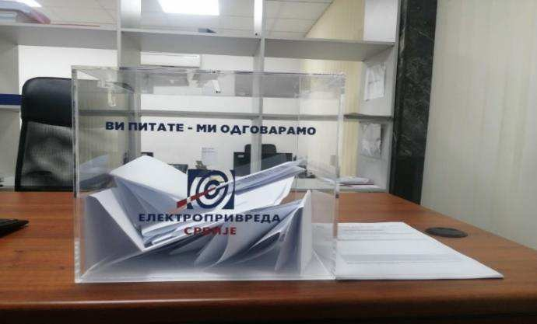
Each organizational unit of PE EPS has publicly available information on the addresses where documents can be submitted. Respecting the needs of all stakeholders, PE EPS has made it possible for submissions to be made orally, which will be recorded in writing by PE EPS officials, thus allowing submissions to be submitted by persons who are prevented for any reason to submit a submission in writing or by e-mail. A submission may be given in a free form or on the form for submissions, which is available for download on the website as well as in the records office of PE EPS. Also, appreciating the needs of the stakeholders, PE EPS additionally introduced and installed boxes for receiving submissions at several locations

Figure 1 The box for the submissions

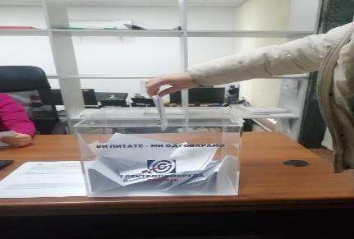
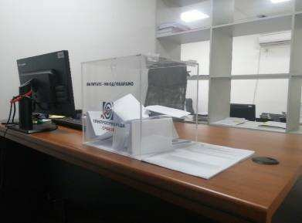

Figure 2 The box for receiving submissions located at the PE EPS registry office

PE EPS reviews all received submissions. For anonymous submissions, PE EPS has limited possibilities to provide adequate notification to the applicant about the outcome, nevertheless, such submissions are also reviewed and acted upon.

By acting in this way with regards to anonymous submissions, PE EPS creates an opportunity for a communication with a wider circle of people, and does not exclude them from activities, but, on the contrary, acts upon their submissions, protecting their decision to remain anonymous.

PE EPS HQ is responsible for requests for free access to information of public importance submitted to PE EPS in accordance with the Law on Free Access to Information of Public Importance, and accordingly, over 500 requests for free access to information of public importance were submitted in 2022.

3.2 Public Relations Sector of PE EPS - Communication with Stakeholders

3.2.1 Responsibilities

The Public Relations Sector of PE EPS is responsible for improving and developing of modern forms of communication for the purpose of timely informing the stakeholders regarding topics important for PE EPS, raising public awareness about the company, improving its reputation and better communication with stakeholders.

The Sector is also responsible for managing internal communications, which includes building good relations within the company. It is also a process of harmonization with corporate values, strengthening the corporate culture and improving the level of identification of employees with the company, building trust and partnership, especially in the environment of structural changes that PE EPS has been facing. The role of the Sector is to responsibly share information in the company, through different levels and functions, as well as to assist other services in their communication, and finally to play a role of the monitoring entity by establishing a feedback mechanism.

External communication target groups:
• Media
• Customers*
• Government institutions
• Local community
• Partners
• Competition
• Non-governmental sector

External communication tools and channels:
• Press releases and information;
• Publishing PR articles in print and electronic media;
• Press conferences;
• Arranging interviews and television reports;
• Conventions;
• Communication via the official e-mail of the Sector – pr@eps.rs;
• The official website of the company www.eps.rs.

Internal communication channels and tools:
• Monthly magazine EPS Energija;
• Monthly issues of Branches’ magazines;
• E-info;
• Internal portal.

3.2.2 Activities Related to Target Groups - Customers

With the opening of the electricity market on January 1, 2015, PE EPS lost its privileged supplier status. In accordance with the newly established goal - market competition, the Sector conducts a biannual survey on “Customer satisfaction with EPS services”, but in 2022, the realization of the survey was postponed until the company's production and business operations stabilized. In 2021, the survey of market and the public opinion on the topic of green energy was conducted, part of which referred to citizens' satisfaction with the services of PE EPS.

Survey goals:
- Degree of awareness among citizens about the concept and importance of electricity from renewable sources
- Degree of citizens' awareness of the green energy market and the green energy offer of PE EPS
- Knowledge of the activity and satisfaction with the services provided by PE EPS;
- Electricity bills payment habits and satisfaction with the attitude of the counter staff;
- Determining the regularity of electricity bills payment of and motivators that would improve the regularity in settling the bills;
- Determining the factors that influence the choice of electricity supplier;

The Public Relations Sector informed the relevant organizational structures in the company about the results of the survey and provided guidelines and logistic support for the improvement of work segments based on the results of customer satisfaction and their wishes and needs.

Based on the results of the survey, the Public Relations Sector recognized the necessity of new communication goals towards customers, and implemented them in its operations as important communication pillars:
- Promotion of green energy for all categories of customers;
- Education on ways of obtaining energy from renewable sources and the positive effects of green energy;
- Education on opening the electricity market for all categories of customers.

3.2.3 Energy Efficiency

Increasing energy efficiency represents one of the strategic goals of the Republic of Serbia, and thus of PE EPS, since it is necessary to establish a balance between the electricity demands and the production capacities of the company.

The Sector continuously implements the following activities:
• PR articles on energy efficiency in print and electronic media;
• Arranging thematic articles and TV reports;
• Updating the segment on the company's website related to energy efficiency;

3.2.4 Other Significant Topics

One of the main tasks of the Public Relations Sector is timely and transparent informing of the media, i.e., customers through the media, on topics of importance to them and the company:
• Business results;
• Service information;
• Plans and investments;
• Corporate Social Responsibility;
• Investment implementation;
• Business environment, etc.
Communication via the official e-mail of the Sector – pr@eps.rs.
The official e-mail of the Public Relations Sector is an important channel of communication to customers as well, since they often use this e-mail address to try to solve their problem or get the necessary information. The Sector mediates in finding solutions for customers by communicating with relevant branches and sectors and by monitoring customer feedback, while giving recommendations for efficient and customized communication with them, which is of mutual interest for both customers and companies.

3.2.5 Internal Communication

Channels and tools of internal communication

Monthly magazine EPS Energija
• Developed and standardized in terms of the structure of the company and the quality of journalistic content in line with international standards;
• The Sector coordinates communication with all parts of the system in order to always place current, transparent and interesting topics that are important for employees;
• EPS Energija also reaches the external public, since it is available in the online edition at www.eps.rs.
Monthly editions of the Branches’ newspapers
• Recognizing the special needs and specifics of all individual branches, the Public Relations Sector has published and edited monthly magazines for individual branches, thus enabling their employees to have additional and more detailed information about their branch and environment, which contributes to respecting differences in large systems.
E-info
• The e-mail channel "E-info" is focused on the most important news regarding production results, business successes and plans of the company and in general - the most important news, which are needed to reach employees as soon as possible, usually on the same day. This meets one of the most important postulates of internal communication - timely informing of employees.
Internal portal
- Notices and official documents placement.

3.3 Cooperation between PE EPS and Stakeholders through Corporate Social Responsibility and Donations
In addition to regular activities, PE EPS is extremely active in its corporate social responsibility. Activities are done in many different ways: through training, presentations, donations, competition organizations, festivals, conferences, camps, and in several different areas such as: education, sports, health and social issues, culture and art, etc. Some of the activities from the mentioned fields that PE EPS tries to support every year are:
- Center for Youth Integration in Belgrade, which includes the drop-in centre for children and youth without permanent residence;
- Center for Palliative Care and Palliative Medicine association BelHospice;
- Assistance to schools – a large number of schools in Serbia were supplied with furniture and new equipment, and help for the reconstruction of school facilities was provided;
- UNICEF - support for humanitarian projects;
- The Teslianum Almanac - support in introducing the works of the scientist Nikola Tesla to the wider reading public, in a creative way;
- Support for the education of the Roma children - under the organization of the association "The Roma Children Humanitarian Center - the Roma of Vlaška", PE EPS has been donating funds for the organization of extra classes, procurement of the school stationery, regular meals and transportation to school to encourage children to continue their education;
- The National Association of Parents with Children with Cancer (NURDOR) - supports the improvement of quality in the treatment of children with cancer;
- Counseling Center for Combating Domestic Violence - support to safe houses activities, where aid to women and children who are victims of violence is provided;
- Organization SOS Children’s Villages Serbia – support to the Children’s Village Kraljevo which provides family accommodation for children without parental care;
- Youth Sports Games - support to the largest sports manifestation for children and youth in this region, which goal is the promotion of a healthy lifestyle, but primarily connecting primary and secondary school students of the region.

Due to extremely difficult circumstances that the electric power system experienced in December 2021, certain activities in the field of socially responsible business were suspended by the decision of the Government of the Republic of Serbia in June 2022. In this regard, the practice of giving donations during 2022 has been suspended, until the budget for these purposes is approved again.

PE EPS regularly provides support for the organization of conferences, professional gatherings and celebrations on the occasion of significant jubilees. Some of the events supported in 2021 are the CIGRE Serbia symposium of the International Council on Large Electric Systems and the Trebinje Energy Summit.

In previous years, PE EPS donations helped the activities of numerous religious and church institutions, both in the field of reconstruction and construction, as well as on the occasion of celebrating various jubilees and events. EPS regularly provided support to the joint project of the University of Belgrade and the Municipality of Ivanjica - “University in the Nature” that lasted for several years.

Other humanitarian activities include support to the Association of Disabled War Veterans and the Multiple Sclerosis Association.

4. Management of PE EPS
Besides the clerk’s office in its registered head office at 13 Balkanska street, the Management of PE EPS also operates at other locations which have clerk’s offices as well, where stakeholders’ submissions are managed in the same manner.

The largest number of submissions of third parties, which were sent directly to the Management of PE EPS, related to employment applications. PE EPS entered these submissions into a special database and informed the relevant stakeholder about it, and hence these submissions are not shown in the table.

Submission date | Applicant | The subject of reclamation/complaint | Decision  (to be entered after the completed reclamation and/or complaint resolution procedure)
31.01.2022 | Lawyer | A request for data for litigation purposes | Notice
18.03.2022 | Natural person through the General Secretariat of the President of the Republic | An application for employment based on the agreement on compensation for expropriated property | Notice
28.03.2022 | Natural person | A request for submission of conditions for concluding the contract on electricity supply | Notice
26.04.2022 | Natural person through the Ministry of State Administration and Local Self-Government | A request for the reconstruction of the low-voltage network in the local community (LC) Velika Braina | Notice
08.07.2022 | The Basic Court in Aleksinac | Information about the ownership of the post (pole) in Aleksinac | Notice
15.07.2022 | The Higher Public Prosecutor's Office | Information about the measuring point | Notice
17.08.2022 | Natural person | A request for an internal act of PE EPS | Notice
10.11.2022 | Natural person | A request for the conclusion of a court settlement | Notice

5. Branches
5.1. Branch EPS Supply
Within the Branch EPS Supply, whose main activity is the supply of electricity to customers on guaranteed, commercial, and last resort supply, in accordance with the Energy Law and other applicable regulations, third party submissions relating to complaints/reclamations on electricity bills etc. are recorded separately.

In order to improve cooperation with customers, institutions, organizations and all those who are directly or indirectly affected by the activities of the Branch, a modern customer service (call center) was planned and realized, and has been implemented in the Branch EPS Supply since November 1, 2020.

5.2. Branch MB Kolubara

The business success of a large system such as the Branch MB Kolubara can also be considered as an integral part of the progress of the entire broader social community.
The socially responsible business of the largest lignite producer in the region is based on compliance with laws, other regulations and internal acts of PE EPS, transparent business, investment in personnel, environmental protection and improvement, high work quality standards and the introduction of a quality improvement system, maintaining and improving customers’ confidence, as well as cooperation with stakeholders and the broader social community.

PE EPS - Branch MB Kolubara undertakes the necessary activities in order to eliminate the consequences of mining operations in the areas of the City Municipality of Lazarevac, City Municipality of Obrenovac, Municipality of Ub and Municipality of Lajkovac, in accordance with the valid agreements concluded with these local self-government units.
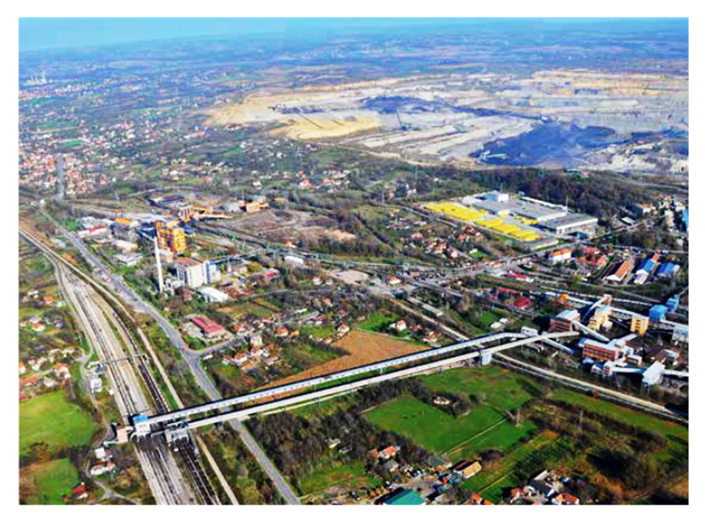
Illustration (photograph Energija Kolubara)

The infrastructural equipping of locations - construction plots, intended for the organized resettlement of residents of those settlements that are relocated due to the further progress of mining and other operations - is in progress, the following acts - contracts and agreements should be highlighted:

- The Contract on regulating mutual relations in connection with the provision of financial resources and development of the construction land according to the Investment program of preparing and equipping the location of the settlement “Kusadak”, LC Šopić, the City Municipality of Lazarevac, with communal infrastructure, No.: III 01 No. 4011 – 1445// 55902/ 2 – 01// 12 01 – 608411/1 – 19 dated November 1, 2019, concluded between the City of Belgrade-the City Administration of Belgrade- Secretariat for Communal and Housing Affairs, Directorate for Building Land and Development of Belgrade PE and PE “EPS” Belgrade-Branch MB Kolubara Lazarevac.
The contract on equipping the “Kusadak” location includes works on forming and infrastructural equipping of construction plots on the location of the “Kusadak” settlement.
In this regard, the following activities have been undertaken or are being undertaken:
- the division (re-parcellation) of cadastral plots for public roads and stream regulation at the location have been carried out;
- a parcellation project and an urban planning project for public purpose buildings at the “Kusadak” location in Lazarevac have been prepared;
- the Urban project and parcellation project for public buildings in blocks 1 and 2 have been confirmed (construction plots: PJN-S No. 1, PJN-O No. 1; PJN-O No. 2, PJN-O No. 4; PJN-Z No. 2 and PJN-Z No. 5);
- the resolving of property/legal relations for 473 cadastral parcels for the needs of building public roads, infrastructure and river regulation is in progress.
- the Agreement on the implementation of the resettlement of the Medoševac settlement number E 04.02.-818292/ 1-22// I-01 number 465-179/ 2022 dated December 12, 2022 has been concluded between PE EPS Branch MB Kolubara, the City Municipality of Lazarevac and the Local Community of Medoševac.

Activities are underway to form the Committee for the relocation of the Medoševac settlement, as well as the Committee for the relocation of the cemetery in Medoševac to a new location, based on the principle of equal number of members from each side, by the decision of the Assembly of the City Municipality of Lazarevac.

PE EPS - Branch MB Kolubara and the City Municipality of Lazarevac concluded the Agreement on financing the printing of the Monograph of the village of Zeoke, number Е04.02-583563/1-22 dated September 7, 2022, based on the Agreement on the Implementation of the Zeoke Village Resettlement Program. The funds for financing the preparation of the monograph are planned and provided by the Three-Year Business Program of PE EPS for the period 2022-2024, that is, the Investment Plan of the Branch MB Kolubara for the year 2022.

5.2.1. Activities regarding the environmental protection and improvement

According to the Law on Mining and Geological Explorations (“Official Gazette of the RS”, No. 101/2015, 95/2018-other law and 40/2021), the Branch MB Kolubara is obliged to carry out works on technical and biological reclamation and landscaping, in the function of environmental protection, regeneration, reclamation and arrangement of degraded land. The recent course of biological reclamation has had two directions: agricultural and forest reclamation. Works on the reclamation of degraded land are carried out after the exploitation is completed, in accordance with the project documentation.

As part of forest reclamation, 65.97 ha have been reclaimed and leased to other users, 753.73 ha of forest and forest land have been reclaimed, 192.34 ha of forest have been expropriated within the Forest Management Unit “MB Kolubara”, i.e., a total area of forest land that has been reclaimed is 1,012.04 ha.

For the purposes of drafting Terms of Reference, a Preliminary design for the construction of a temporary warehouse of industrial waste in the Branch MB Kolubara has been prepared. The warehouse will be intended for the disposal of hazardous and non-hazardous industrial waste from all locations in the Branch MB Kolubara, in accordance with the provisions of the Law on Waste Management (“Official Gazette of the RS”, No. 36/2009, 88/2010, 14/2016 and 95/2018 - other law).
5.2.2. Activities of the Branch MB Kolubara in terms of Cooperation with Educational Institutions

MB "Kolubara", in cooperation with Technical School "Kolubara" from Lazarevac, High School "17. septembar" from Lajkovac and Technical School "Mileta Nikolić" from Arandjelovac, and based on the Rulebook on the Curriculum and Program of Vocational Subjects of Secondary Vocational Education and the Plan and Program of Teaching and Learning, achieves successful cooperation regarding the implementation of dual education.

In the implementation of learning through work (dual education model) of students in the 2021/2022 school year, based on the acquired accreditations and concluded contracts on dual education with schools and contracts on learning through work, concluded with students / their legal representatives, in the organizational unit "Kolubara Metal" (Production Plant and Elmont Plant) and the "Processing Plan" organizational unit, during the three-year implementation of the dual education program, in June 2022, a total of ninety-three students of the educational profile "Industrial Mechanic" (5 students , "Machining Operator" (16 students), "Locksmith Welder" (49 students), "Network and Plant Electrician" (10 students) and "Electrician" (13 students).

Also, the implementation of the dual education program for the new generation of educational profile "Locksmith and welder" and "Machining operator" is in progress for seven students of High School "17. September" from Lajkovac in the Branch MB Kolubara, while for 41 students of the educational profile "Electrical Fitter of Networks and Plants", a contract on learning through work was concluded between PE EPS - Branch MB Kolubara and Technical School "Kolubara" Lazarevac (PE EPS number 04.02-644979/ 1-22 of 03.10.2022), under which the mentioned students of the "Kolubara" Technical School will do internships in the "Kolubara Metal" Organizational Unit, Elmont Plant during the 2022/2023 school year.

During 2022, the necessary activities were carried out in connection with the accreditation process of new locations in the Branch MB Kolubara, and according to the expressed needs in 2020 and 2021, for the purpose of inclusion in the implementation of the dual education program, for sixty-eight students of the educational profile "Locksmith and Welder", "Mechanic of motor vehicles" and "Electrical Fitter of Networks" in the facilities of the organizational unit "Kolubara Metal", the Elmont plant, the "Processing Plant" organizational unit, the "Open pit mines Barosevac" organizational unit, the Auxiliary Machinery plant.

On the basis of the concluded Agreement on business and technical cooperation, the Branch MB Kolubara also provided practical classes in the organizational unit "Kolubara Metal" for students of the High School "One Thousand and Three Hundred Corporals" Ljig, educational profile "Welder".

As part of the above-mentioned activities, students of the eighth grade of elementary schools "Dušan Danilović" from Radljevo and "Sveti Sava" from Pambukovica visited the Branch MB "Kolubara" at the end of May 2022 as part of the implementation of the professional orientation program, while on June 3, 2022, the third and fourth year students of mining at the Faculty of Technical Sciences in Kosovska Mitrovica of the University of Pristina visited the Branch MB "Kolubara", as part of their professional internship within the subject "Technology of Surface Exploitation".

Stakeholder submissions

Submission date | Applicant | The subject of reclamation/complaint | Decision  (to be entered after the completed reclamation and/or complaint resolution procedure)
10.02.2022 | Natural person | Expropriation | Response sent to the stakeholder
11.02.2022  . | Local self-government | Removal of evicted and half-demolished buildings in Vreoci | Response sent to the stakeholder
14.03.2022 | Natural person | Purchase of a solidarity apartment | Response sent to the stakeholder
16.03.2022 | Natural person | Expropriation | Response sent to the stakeholder
16.03.2022 | Natural person | Expropriation | Response sent to the stakeholder
18.03.2022 | Association of Citizens | Solidarity apartments | Response sent to the stakeholder
23.03.2022 | Natural person | Buying an apartment | Response sent to the stakeholder
28.03.2022 | Natural person | Air quality complaint | Response sent to the stakeholder
29.03.2022 | Local self-government | Request for marking the potential industrial zone "Kusanja" | Response sent to the stakeholder
13.04.2022 | Natural person | Purchase of solidarity apartments | Response sent to the stakeholder
28.04.2022 | Natural person | Expropriation | Response sent to the stakeholder
02.06.2022 | Natural person | Determination of public interest in expropriation | Response sent to the stakeholder
13.07.2022 | Local self-government | Request for provision of necessary accommodation | Response sent to the stakeholder

5.3. Branch HPP Djerdap

The report was compiled on the basis of data obtained from organizational units of the Branch HPP Djerdap that come into contact with stakeholders (HPP Djerdap 1, HPP Djerdap 2, Vlasinske HPP, HPP Pirot, Directorate for Modernization and Revitalization, Directorate for Production, Directorate for Legal and General Affairs, Sector for Coastal Maintenance, Technical Service, Center for Environmental Protection, Center for Quality, etc.).

In the period from January 1, 2022 until December 31, 2022, the following collaborations with stakeholders were recorded in the Branch HPP Djerdap:

- During 2022, PE EPS Belgrade - Branch HPP Djerdap had a successful cooperation with the Institute for Multidisciplinary Research of the University of Belgrade within the project financed by the European Commission entitled "Pilot Project: Making the Iron Gates dams passable for Danube sturgeon (Contract No. 07027756 /2021 /844774/ETU/ENV.C.1)''. The Institute for Multidisciplinary Research of the University of Belgrade was engaged as a subcontractor by one of the project partners, the National Institute of the Danube Delta from Romania, to participate in activities related to fish telemetry research. Telemetry research involves placing receivers in the Danube and placing transmitters in animals in order to monitor their movements. The project is implemented in the area of the HPP "Djerdap 1" and HPP "Djerdap 2" dams. In addition to the National Institute of the Danube Delta, the "Jaroslav Černi" Institute, the International Commission for the Protection of the Danube River and the company "CDM Smith" are participating in the project as the project manager. In the course of 2022, the project participants from IMSI came for several days of field research that involved setting up and controlling the equipment, downloading data from the receiver and installing the transmitter. The Institute for Multidisciplinary Research, as part of its activities in this project, prepared an annual report on fishing for scientific research purposes, no. 2718/1 dated 15.12.2022.
- Activities on the maintenance and protection of drainage systems, embankments, coastal fortifications and other hydrotechnical facilities were continued in order to protect the coast from the harmful effects of water and to protect the reservoir. The facilities are also used by local residents, local self-governments and state authorities practically on the entire coast of HPP "Djerdap 1" and HPP "Djerdap 2".
- The monitoring and notification system is implemented in order to provide a Monitoring and Notification System for the population in the area threatened by the collapse or overflow of the HPP "Djerdap 2" dam. The Branch HPP Djerdap was obliged to build a monitoring and notification system during the construction of the "Djerdap 2" Hydroelectric Power Plant, as an integral part of the monitoring and notification system of the municipality of Negotin. As of 2019, a third of the system has been built so far. At the request of Ratel, a technical review of the radio frequencies used in the system in the municipality was carried out, specifically in the local communities of Mihajlovac, Slatina, Prahovo, as well as at the HPP "Djerdap 2" dam itself. Radio stations were reprogrammed at the locations of Slatina, Novi Mihajlovac, towards HPP "Djerdap 2", Prahovo, as well as the municipality of Negotin and Bukovo hill.
- In the period from January 1, 2022 to December 31, 2022, a total of 1,828 ships were transshipped by the HPP "Djerdap 2" ship lock. Of these, 6,523 vessels, 10,535,822 tons of carrying capacity, or 4,868,881 tons of goods, were transferred. In 29 years of operation, 188,676 vessels with more than 127 million tons of goods were transported through it.
- Activities on the maintenance and protection of drainage systems, embankments, slope protections and other hydrotechnical facilities were continued in order to protect the coast from the harmful effects of water and to protect the reservoir. The facilities are also used by local residents, local self-governments and state authorities practically on the entire coast of HPP "Djerdap 1" and HPP "Djerdap 2".
- Works were carried out on the reconstruction of the collector road in the K-3 landslide zone in Donji Milanovac, the municipality of Majdanpek.
- The archival documentation of the Church of the Holy Trinity in Negotin was moved to the reconstructed premises of the church gate, at the request of the Patriarchate of the Serbian Orthodox Church.
- On May 28, 2022, a group of students from the third year of the Faculty of Electronic Engineering in Nis - study programme Electrical Power Engineering, visited the facilities of HPP "Pirot" in order to learn more about the electricity production process, technology and equipment.
- At the request of the Public Enterprise for Forest Management "Srbijasume" - Šumsko gazdinstvo Pirot, during May and June 2022, water discharge from the artificial reservoir of Lake Zavoj was reduced due to the spawning of fish of the genus "Cipirinidae", bream and carp.
- In cooperation with the House of Culture in Grdelica, and as part of the "Grdelica Summer 2022" under the auspices of the City of Leskovac, on July 16, 2022, "Vlasinske HPP" released water from the reservoir in order to raise the water level of the South Morava, all in order to enable holding the sixteenth traditional regatta on the South Morava from Grdelica to Dobrotin.
- In the period from June 29 to July 1, 2022, as part of a teacher's excursion, 30 students of the Polytechnic High School from Subotica visited the facilities of "Vlasinske HPP" in order to learn about the way of operation and functioning of hydroelectric power plants from the "Vlasinske HPP" system, specifically from HPP "Vrla 1", HPP "Vrla 2", HPP "Vrla 3" and HPP "Vrla 4".
- On December 28, 2022, at the facility of HPP "Vrla 4" in the village of Polom, a joint demonstration-practical fire drill was held with members of the Department for Emergency Situations, Fire and Rescue Unit of the Ministry of the Interior of the Republic of Serbia from Vladicin Han.

5.3.1.Receipt and Processing of Submissions
The Branch HPP Djerdap is addressed in writing by stakeholders with requests that most often relate to the expropriation of land and buildings located on the coast of the Branch HPP Djerdap. In addition, stakeholders apply in the form of requests for compensation for damage, rehabilitation of construction buildings, houses, coastal forts or for compensation for material damage to agricultural land. There is a certain number of requests related to the protection of the coast and the riverbank, all with the aim of protecting private or state property from the harmful effects of water, as well as the protection of the reservoir itself, as well as requests for cooperation with the local self-government in order to implement works and projects of public interest in the coastal zone.

Stakeholder submissions

Date of submission receipt | Applicant | A brief description of the submission / issue | Outcomes of implemented activities (the result of resolution of the submission)
22.02.2022 | State Attorney's Office | The applicant requested information on the completion of the procedure for annulment of the decision of CM Palilula | Notice
28.02.2022 | Ministry of Finance | The applicant requested a statement for cp 1427 CM Klicevac, regarding the expropriation procedure on the proposal of the Branch Kostolac ТPPs-OPMs | Notice
27.06.2022 | Natural person | The applicant requested the issuance of a copy of the contract on awarding the land plot in Donji Milanovac | Notice
27.10.2022 | Natural person | The applicant requested the issuance of a certificate of payment for the apartment under the contract for the purchase and sale of the apartment | Documents delivered to the applicant
08.11.2022 | Natural person | The applicant requested the issuance of a copy of the decision on the allocation of the cadastral plot in Donji Milanovac | Notice

5.4. Branch Panonske CHP

In the period from January 1 to December 31, 2022, the Branch Panonske CHP carried out the following activities, which also included communication with stakeholders:

- Regular communication with competent institutions and partners was maintained
- Due to changes in the energy market in 2022 and a significant increase in the volume of production, communication with customers and suppliers has also been intensified.
- On the initiative of the Ministry of Energy, and by order of the Management of PE EPS, representatives of the Panonshe CHP attended a meeting where the realization of a potential project for the construction of a solar-thermal plant in Novi Sad was considered. JKP Novi Sad thermal power plant could be the main contractor, while Panonske CHP has been identified as a potential partner
- Cooperation with PUC City Heating Plant Zrenjanin has been renewed
- Cooperation with the Faculty of Technical Sciences in Novi Sad continued in order to provide students with the opportunity to complete professional internship in the Branch's facilities.
- In two thermal power plants (TPP-HP Novi Sad and TPP-HP Sremska Mitrovica), the implementation of the dual education program for children attending secondary vocational schools has been started.
- Internal communication, apart from regular activities of informing employees about the most important events in the company, had an additional goal in 2022 - raising awareness of the importance of saving electricity in the workplace

Due to the specificity of their production process, Panonske CHP have limited and sporadic activities that include the direct involvement of stakeholders.

Regular activities, including communication with stakeholders, were carried out according to the plan.

5.5. Branch Drinsko-Limske HPPs

Drinsko-Limske HPP Bajina Basta (DLHPP) produces electricity and drinking water ("Perucac" and "Tara" waterworks).
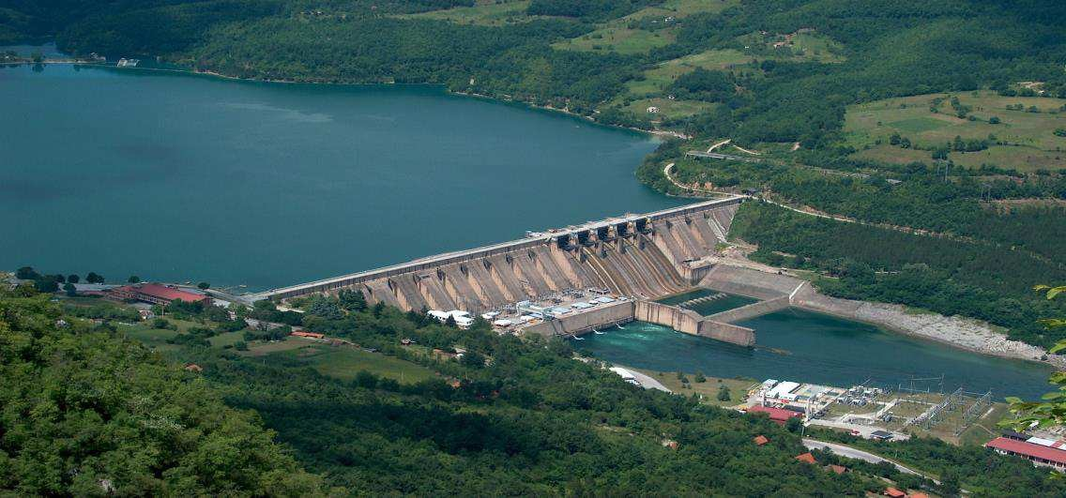
HPP Bajina Basta

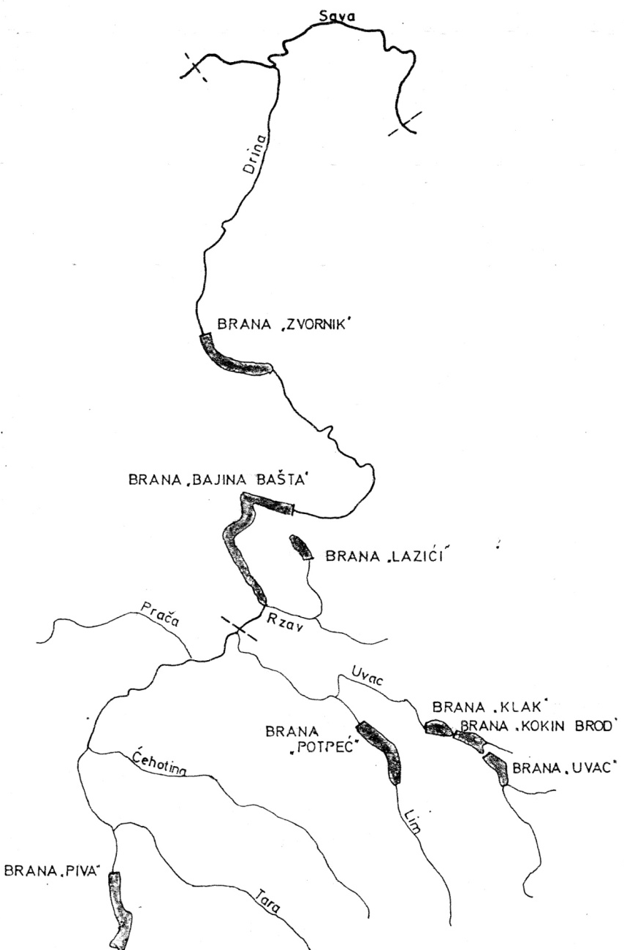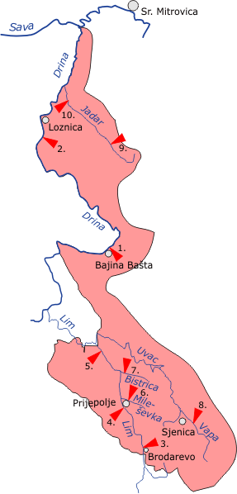
Image no. 1. Dams in the Drina river Image no. 2. The drainage basin of the river Drina

A brief description of activities and projects of the Branch

The Branch “Drinsko-Limske HPPs” Bajina Basta directs its activities to tasks that, in addition to fulfilling legal obligations, contribute to a better quality of life for the local population and environmental protection.

In 2022, the following activities are planned and are in the process of being implemented

- Development of a detailed regulation plan with conceptual solutions for the right bank of the Perućac reservoir from the B. Bašta HPP dam to the entrance of the Derventa river into the reservoir
- Cleaning of floating sediment from the water surfaces of reservoirs in the Drina river basin, as well as the removal of logs and floating objects from the overflow zone (at the time of high water when large amounts of waste arrive)
- Winter and summer maintenance of roads within the hydroelectric power plants of the DLHPP Branch
- The project to normalize the work of HPP BB, with a preliminary analysis for the rehabilitation and monitoring of the Mandici landslide, as well as a risk assessment
- Boatman services on the ship Uvac

In the coming period, it is planned to continue the activities to remove the consequences of landslides on the shore of the HPP Bajina Bašta lake, reconstruction and rehabilitation of roads around the reservoirs of the DLHPP Branch, landscaping of the banks around the reservoirs, cleaning of floating sediment from water bodies brought by large waters (especially in HPP "Potpec"), further works on the Tara Waterworks, winter and summer road maintenance within the hydroelectric power plants of the DLHPP Branch.

Stakeholder submissions

Submission receipt date | Name of the person / organization wich submitted the submission | A brief description of the submission | The date the submission was replied to and closed
19.01.2022 | PE National Park Tara | A call to review the membership in the National Park Tara Counsil of Users | Reply submitted
28.02.2022 | Rača local community | A request for a professional technical team to ascertain losses on the water supply network | Request implemented
10.03.2022 | Bajina Bašta Municipality | A request for assistance in clearing snowfall for the winter period 2021/2022 | Request implemented
29.04.2022 | Zaovine local community | A request to resolve the water supply of the hamlets (Popovići, Spajići, Graovac), schools in Luka and Lazići in the village of Zaovine | Request in the process of implementation
04.05.2022 | Višegradska  Serbian Ortodox Church Municipality | A request for water level maintenance on 28 May 2022 | Implemented
23.06.2022 | The city of Užice  City administration for urbanism, construction and property-legal affairs  Department for object legalization | A request for approval of illegal residential object legalization | Implemented, the reply was submitted by the Construction Maintenance Service
29.06.2022 | Тara Ultra Trail 2022 | A request to pass over the Lazića dam | Request implemented
16.08.2022 | The city of Užice  City administration for urbanism, construction and property-legal affairs, Department for object legalization | A request for approval for the legalization of the facility at CM Sevojno | Request rejected (facility in the transmission line protection zone)
29.08.2022 | Radio Television of Serbia | A request for temporary switching of the optical cable on the road Perućac - HPP dam | Request implemented
07.10.2022 | Hunting association "Kozomor" Nova Varoš | A request for lease of office space in Nova Varoš | Reply submitted

5.6. Branch Kostolac ТPPs-OPMs

In the Branch Kostolac ТPPs-OCMs, a project is being implemented to build a power plant that will use wind energy to produce electricity. When planning the spatial disposition of twenty wind turbines, the principles of preventive environmental protection and its factors were followed, in order to prevent or minimize possible negative impacts. The project will be implemented on devastated land that was previously used for mining activities. The implementation of the Project will contribute to the improvement of the economic activity of the municipality of Kostolac, as well as enable not only the engagement of domestic companies during construction, but also the development and improvement of local infrastructure.

In the Branch Kostolac ТPPs-OCMs informing the stakeholders in 2022 was mainly done through the Department for Public Relations. By understanding the importance of public opinion and media, the cooperation with the relevant media centers was established in order to inform the public timely and continuously on significant subjects.

Also, information was published by the web site www.eps.rs and electronic editions of “EPS Energija“ and “EPS Energija Kostolac“, and also by internal networks “e-info“ and “INFO TEKO“, used for regular issuance of service information significant for employees and the public.

Stakeholder submissions

Date of submission receipt | Name of the person who submitted the submission | A brief description of the submission | The outcome of the activity carried out in order to solve the case
02.03.2022 | The General Secretariat of the President of the Republic of Serbia | A Letter from PE EPS regarding the application sent by a natural person on the establishment of an employment relationship | A reply was sent to the General Secretariat of the President of the Republic of Serbia
25.03.2022 | The General Secretariat of the President of the Republic of Serbia | A Letter regarding the submission sent by a natural person for assisstance regarding the son's employment | A reply was sent to the General Secretariat of the President of the Republic of Serbia
10.04.2022 | The General Secretariat of the President of the Republic of Serbia | A Letter regarding the submission sent by a natural person on the establishment of an employment relationship | A reply was sent to the General Secretariat of the President of the Republic of Serbia
13.04.2022 | The Government of the Republic of Serbia  Office of the President | A Letter regarding the submission sent by a natural person on the establishment of an employment relationship | A reply was sent to the Office of the Prime Minister of the RS
19.04.2022 | The General Secretariat of the President of the Republic of Serbia | A Letter regarding the submission sent by a natural person on the establishment of an employment relationship | A reply was sent to the General Secretariat of the President of the Republic of Serbia
21.04.2022 | Republic of Serbia  Ministry of Mining and Energy | A Letter regarding the submission sent by a natural person on the establishment of an employment relationship | A reply was sent to the Ministry of Mining and Energy
29.04.2022 | Republic of Serbia  Ministry of Mining and Energy | A Letter regarding the submission sent by a natural person on the establishment of an employment relationship | A reply was sent to the Ministry of Mining and Energy
04.05.2022 | The General Secretariat of the President of the Republic of Serbia | A Letter regarding the submission sent by a natural person on the establishment of an employment relationship | A reply was sent to the General Secretariat of the President of the Republic of Serbia
17.05.2022 | Natural Person | A claim for damages | Reply to the natural person
27.05.2022 | Institute of Archaeology | A request to appoint a person for the needs of the Project for Innovations Acceleration and Encouraging the Growth of Entrepreneurship of the Institute of Archaeology | Implemented
13.06.2022. | The General Secretariat of the President of the Republic of Serbia | A Letter from PE EPS regarding the submission sent by a natural person on the establishment of an employment relationship | A reply was sent to the General Secretariat of the President of the Republic of Serbia
28.06.2022 | The Government of the Republic of Serbia  Office of the President | A Letter regarding the submission sent by a natural person on the establishment of an employment relationship | A reply was sent to the Office of the Prime Minister of the RS
06.07.2022 | Psychological Center Kostolac | A request for attendance and participation in the event on the occasion of Miners Day on August 6, 2022 | After the consent of the Sector was obtained, the performance of the choir was included in the program as part of the "My Serbia" project, aimed at promoting patriotic values among the youth of the Braničevo district in the realization of the "Psychological Center" Kostolac
26.07.2022 | The Government of the Republic of Serbia  Office of the Prime Minister  National Employment Service | A submission regarding the request for assistance in employment of the wife | A reply was sent to the Government of the RS  Office of the Prime Minister of the RS  Reply to the natural person
26.07.2022 | Lawyer | A request for transfer of ownership to the beneficiary of expropriation | Reply to the applicant
26.07.2022 | TE2 media Požarevac | A request to appoint interlocutors from the Branch for the needs of the realization of the media project Development Plans - improvement of communal systems and services in order to improve the quality of life of the citizens of Požarevac | Replied electronically
27.07.2022 | The General Secretariat of the President of the Republic of Serbia | A Letter regarding the submission sent by a natural person on the establishment of an employment relationship | A reply was sent to the General Secretariat of the President of the Republic of Serbia
01.08.2022 | Radio Television of Serbia, Scientific editorial office | A request to allow the filming of an archaeological site for the purposes of the show Archaeological discoveries of science 2022. Scientific editorial office of RTS. | Filming approved
01.11.2022 | Radio Television of Serbia | A request for answers to questions regarding coal for people in retirement and unions | The Public Relations Service submitted the requested replies electronically
04.11.2022 | Town of Požarevac, Mayor of Požarevac | A request for delivery of coal to customers with the lowest incomes whose livelihood is threatened | A Decision on the sale of raw coal to the Association of Pensioners of the Town of Požarevac, who buy coal for the needs of their households for the year 2022
02.12.2022 | Natural person | A damage report on plot no. 1118, the village of Kostolac due to the spillage from the ash pipe no. 246500-E.05.01.-828398/1-2022 | A compensation claim by the insurance company is in process.
14.12.2022 | Natural person | Request for damage assessment on the plot of CM Klenovnik | Official note on the condition of the plot CM Klenovnik
26.12.2022 | Ministry of Construction, Transport and Infrastructure of the Republic of Serbia | Request for recognition of the status of a party in the case following the request for the issuance of a use permit | A reply forwarded to the applicant

5.7.Branch TENT

This report presents the activities of PE EPS - Branch TENT Obrenovac with stakeholders in the period 1st January – 31st December 2022.
Main activities with stakeholders:

- With the Ministry of Mining and Energy and other Ministries, in writing and orally by the authorized persons from the Branch for executing regular production and operation activities and implementation of investment projects.

-All received submissions were immediately processed by the competent services and they were acted upon by implementing the basic requests of shareholders. Two binding decisions of the environmental protection inspection were made, the implementation of which is in progress, and one of them, in addition to the request to extend the deadline for action, was also appealed to.

-During 2022, the construction of the flue gas desulfurization plant continued on four units of the thermal power plant TENT A, A3-A6, which will have multiple positive effects on the field of environmental protection. Progress was evident in every segment, and completion is expected in 2023. At the end of the year, the progress of the works was 91.17%, and the progress of the overall physical progress was 89.46%.

- In April 2022, three construction permits related to the construction of flue gas desulfurization plants for both units of the TPP "Nikola Tesla B" were obtained. The construction of this facility is expected to reduce the total amount of sulfur dioxide emissions from 5000 mg/Nm3 to 130 mg/Nm3, in addition, the level of emitted solid particles into the atmosphere from the current 50 mg/Nm3 will decrease to less than 20 mg/ Nm3. According to the contract, the deadline for the completion of the project is forseen for March 2024. At the end of the year, the progress of the works was 19.91%, and the progress of the total physical progress was 49.11%.

- A public discussion and presentation of the Environmental Impact Assessment Study of the project "Construction of a wastewater treatment plant in the complex TENT B Ušće was held on April 28, 2022 in the Town Municipality of Obrenovac. There were no objections to the study. The consent for the study was obtained from the Ministry of Environmental Protection by the decision of 06.12.2022.

The Branch TENT, in addition to environmental protection, takes care of the local community through the production of heating by the TPP Nikola Tesla A for the Obrenovac A district heating system, and TPP Kolubara in Veliki Crljeni through the production, distribution and supply of heating and maintaining the district heating system for natural and legal persons (the elementary school, outpatient clinic of the Health Center Dr Djordje Kovačević in Lazarevac, pre-school institution, kindergarten, pharmacy, etc.) in Veliki Crljeni.

During the clearing of expropriated land for the construction of cassette C of the TEK ash landfill, on the plot 2554/5 CM Stepojevac, two memorials were discovered and the remains of the deceased Pavle Brkić who was buried in the 18th century. By obtaining the necessary decisions, conditions and consents, the exhumation and transfer of the remains and memorials to the local cemetery in Stepojevac was carried out. All activities were carried out in the period from August 1, 2022 until 25 October 2022.

In the observed period, in the Branch TENT 14 students from the University of Belgrade and professional academies completed their apprenticeship. Vocational practice for high school students - Obrenovac Technical High School was implemented for a total of 188 students (136 students in block classes, and 52 students in dual education). Visits to the Branch TENT-11 by students of the Faculty of Mechanical Engineering in Belgrade, 24 students of the Faculty of Electrical Engineering, 77 students of the Obrenovac Agricultural and Chemical High School, and 35 students and 3 teachers of the Elementary School "Živojin Perić" of Stubline were carried out and organized.

Stakeholder submissions
Date of Submission receipt | Applicant | A brief description of the submission / issue | Planned activities | Conducted activities in order to resolve the submission | The outcomes of the conducted activities (the result of submission resolution)
10.06.2022 | Natural person  Republic Inspection for Environmental Protection | Air pollution as a result of ash spreading from the TEK landfill | Acting upon the requests of the republic inspector | Republic Inspector for EP, on June 10, 2022 carried out an extraordinary inspection and noted in the minutes that no illegalities were detected in connection with the actions of TEK according to the provisions of the Law on Environmental Impact Assessment. | There were no further requests to act upon
18.02.2022 | Natural person | Illegal usurpation and conversion of a green area into a parking lot by the tenant of the Settlement TEK who did not comply with the decision of the communal inspector | Going to the site, checking the validity of the allegation | A request for execution of the decision was submitted to the Communal Inspection of the Municipality of Lazarevac No. Е 03.04.-110660/1 on February 22, 2022 | There were no further complaints of the applicant
18.02.2022 | Natural person  Department for communal inspection supervision | Spilling of fecal content from the fecal collector owned by TEK on the cadastral plot in private ownership | Checking the allegations, going to the site, checking the factual situation and the validity of the report, determining the spilling cause | Sewage shaft at CP 428/1 KO Veliki Crljeni cleaned again Department for inspection supervision of CM Lazarevac submitted a call for immediate action no. E.03.04.-144545/1-22 from 08.03.2022. for urgent inspection supervision and the imposition of measures by PD "Deviks" Lazarevac due to the blockage of the shaft. | A natural person filed a claim for damages against PE EPS to the Basic Court in Lazarevac
- | Natural person  Republic Inspection for Environmental Protection | Air pollution as a result of TPP Kolubara operation | Acting upon the requests of the republic inspector | Republic Inspector for EP on 03.04.2022 performed the mixed insp. supervision and noted in the minutes two illegalities regarding the actions of TEK according to the provisions of the Air Protection Act. Two measures were ordered. | The deadline for the elimination of illegality has been extended until June 30, 2023
21.07.2022 | Natural person  Republic Inspection for Environmental Protection | Emission of black smoke from TENT A | Acting upon the requests of the republic inspector | The inspector did not go out to the site. Requested data submitted to the inspector. The minutes have not been done | There was no further action by the inspector

6. KEY ACTIVITIES PLANNED FOR THE UPCOMING PERIOD

PE ЕPS continuously implements activities in communication with stakeholders.

PE EPS changed its legal form to a joint stock company on April 13, 2023, which now operates under the full business name Joint stock company “Elektroprivreda Srbije”, Belgrade, shall continue to adjust and update manners of communication, in order to fulfill its obligations in the most efficient way possible, to establish examples of good practice and continue the good trend of corporate social responsibility.

